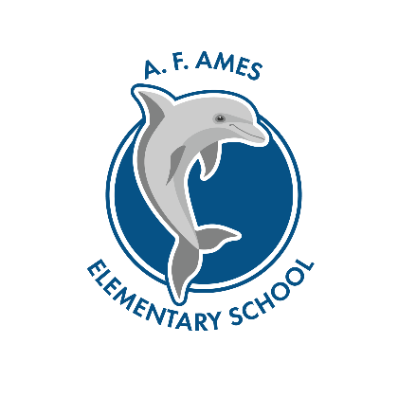
Wednesday, March 1, 2023
Ames PTA Board Meeting Agenda
  - Welcome by Co-Presidents – Deanna Melvin & Marissa Serio
  - Secretary – Kelly Rehmer
  - January and February meeting minutes approved
  - 4th and 5th grades Spring Concert yard signs go on sale April 3rd
  - Treasurer – April Knowles
- Budget
- VP Of Communications - CO – Deb Ziff Soriano & Lou Fitzgerald
- VP Cultural Arts & VP Educational Programs –
  - Fun Lunch was 2/24 LaBarra Pizza
  - Heritage Night- March 23rd 6-7:30pm. We need YOU, sign up today!
  - Artist in Residence – week of March 20th
  - Science Fair: March 9th open to 3-5th graders
    - ?s: Robert Kalnitz (kainitz@hotmail.com) or Sara Mudler (sarah.mudler@gmail.com)
- VP Fundraising & Events – Alanna Cotham
  - Restaurant night
    - Lou Malnati’s March 6th
    - Panera Bread April 10th
- In School Volunteers - Maria Munch
  - Field Day
  - Yearbook Update
- VP Hospitality – Michelle Galindo
  - Teacher Appreciation Week coming out soon

